Beyond the Binary: Gender and Legal Personhood in Islamic Law: Book Review
Zulfa Asifa Albania*
Universitas Islam Negeri Raden Mas Said Surakarta, Indonesia
zulfaasifa16@gmail.com

Ika Nur Pujiastuti
Universitas Islam Negeri Raden Mas Said Surakarta, Indonesia
nurpujiastutiika@gmail.com
submitted: 20 March 2025, revised: 10 June 2025, published: 28 June 2025
*corresponding author

Beyond the Binary: Gender and Legal Personhood in Islamic Law, By Saadia Yacoob, Univ of California Press, 2024, 178, ISBN. 9780520393813, book link: https://play.google.com/store/books/details?id=q9D0EAAAQBAJ
INTRODUCTION
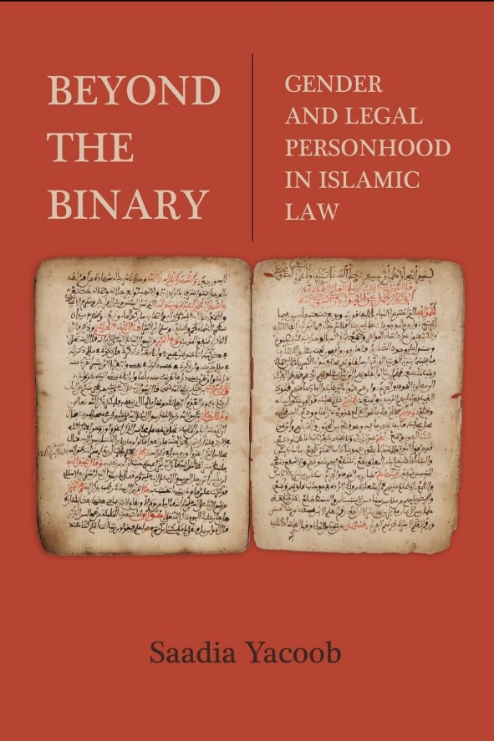
"Beyond The Binary: Gender and Legal Personhood in Islamic Law" by Saadia Yacoob is a groundbreaking work that challenges the traditional binary understanding of gender in Islamic law and explores the legal personhood of individuals who fall outside this binary. The book argues that Islamic law, when interpreted through a lens of justice and equity, can accommodate diverse gender identities and experiences. Yacoob (2024) meticulously examines the historical and contemporary interpretations of gender in Islamic law, highlighting the limitations of the binary framework and its impact on the lives of individuals who do not conform to traditional gender norms. She then presents a compelling case for a more inclusive and nuanced understanding of gender and legal personhood within Islamic law, drawing on Islamic legal principles, feminist scholarship, and contemporary legal developments. This book explores how Islamic jurisprudence constructs gender identity and legal status beyond a simple male/female binary, showing that Islamic law recognizes a variety of gendered legal subjects. Yacoob challenges the idea that gender is the primary organizing principle in Islamic law, showing that other social identities such as age and slavery also play a critical role in defining legal personhood. Through her analysis, Yacoob offers a more nuanced understanding of the Islamic legal tradition, suggesting that the construction of legal personality is relational and situational, shaped by a complex web of social relations. The book advocates an approach that relegates gender as a category of analysis in the study of Islamic law to fully understand the complex and dynamic web of relationships through which power is exercised in legal discourse. As such, “Beyond the Binary” provides new insights into how Islamic law views and regulates gender identity, challenging readers to rethink their assumptions about gender and law in the Islamic context.
The book “Beyond the Binary: Gender and Legal Personhood in Islamic Law” by Saadia Yacoob offers the important benefit that it provides a deep understanding of how Islamic law conceptualizes and navigates gender and social identities. It helps readers understand the complexities behind a legal system that is often viewed in a monolithic and patriarchal manner. The book challenges readers to rethink gender categories and how the legal system interacts with these identities in a more nuanced and contextualized way. Yacoob advocates for an intersectional approach in studying law and society, showing how identities such as age and freedom/slavery status intersect with gender. This expands the understanding of power dynamics and provides a richer framework for analyzing social and legal relations. By exploring the construction of gender in Islamic law, this book makes an important contribution to gender studies, adding to the discussion of how gender and law interact across different legal and cultural traditions. As such, “Beyond the Binary” offers valuable contributions and new insights that enrich our understanding of Islamic law, gender, and the complexity of the interaction between the two, making it essential reading for anyone interested in these areas.
The book is divided into 4 chapters. Each chapter often begins with an introduction that sets out the purpose of the chapter, the research questions to be answered, and the significance of the topic in the context of the whole book. The author details the theoretical framework used to analyze the chapter topic, explaining the key concepts and how they are applied in the analysis. In chapters that require context, the author provides historical or legal background relevant to the chapter topic, ensuring the reader understands the essential basis for the discussion that follows. The main body of the chapter will contain an in-depth analysis of the topic, using data, legal texts, case studies, or other sources. The author will outline the argument, support it with evidence, and show how the findings inform or challenge existing understandings. Each authored chapter ends with a conclusion that summarizes the main findings, discusses their implications in a broader context, and perhaps relates them to a later chapter in the book.
Chapter 1 of this book explores the normative construction of gender in early Hanafi legal discourse. Through analysis of legal discussions of illicit sexual relations, covering women's bodies, and gendered prayer postures, this chapter argues that masculinity in Hanafi legal discourse is characterized as active, self-determined, and socially dominant. Femininity is characterized by passivity and subordination. This gender binary construction often serves the role of justifying legal precedent. The chapter also notes where this binary construction breaks down by focusing on examples where Hanafi jurists make arguments that contradict this narrative. In demonstrating this dissonance in the construction of gender, this chapter argues that this abandonment of the gender binary opens up the possibility of questioning the hermeneutical role occupied by gender in legal discourse, a question that animates the remaining chapters in the book. In a discussion of illicit sexual relations, Yacoob shows how Hanafi law uses an active/passive gender binary to determine responsibility and punishment in cases of sexual relations outside marriage. Active masculinity positions men as more responsible, while passive femininity often reduces women's responsibility in this context.
in Chapter 1, the active/passive binary approach raises questions about justice and equality in law. If responsibility and punishment for sexual relations outside marriage are based on rigid gender roles, this can lead to injustice, where one gender is systematically seen as less responsible or deserving of lighter punishment than the other. This critique calls for critical reflection on how the law can be more just and equitable by not relying on rigid gender assumptions. This can give rise to various arguments such as the opinion of Mahmud Syaltut quoted by Quraish Shihab, namely: “Human nature between men and women can almost be said to be the same. Allah has given women such bestowed upon men both of them bestowed by God with sufficient potential and ability to assume responsibility and that makes the second This gender can carry out activities that general or specific. Therefore, the laws The Shari'a also places both in one framework. This one (men) sell and buy, marry and marry, violate and be punished, prosecute and witness, and which that (woman) is also like that, can sell and buy, marry and marry, violate and be punished as well demanding and witnessing."
Chapter 2 explores slavery as a category that undermines legal personality in Hanafi law. This chapter focuses on two main case studies: legal coercion in the marriages of enslaved people and the forced bodily exposure of enslaved women. Through this case study, this chapter shows that slavery undermined the legal personhood of enslaved people by subjecting them to the power of male and female slaves alike. In exploring the intersection of slavery and gender, we can see that the active/passive binary can be reversed not only in making certain male subjects passive and subordinate but also by giving some female subjects power and dominance over certain male subjects. Exploring the intersection of these two social identities also shows that slavery damaged individuals' legal personhood differently depending on whether they were male or female. Enslaved men and women thus occupied different legal personalities despite their shared status as enslaved individuals.
This chapter delves specifically into the intersection between slavery and gender, showing how the status of slavery complicated understandings of masculinity and femininity. Yacoob explores how enslaved men and women were treated differently under the law, with a particular focus on issues such as marriage, concubinage, and access to freedom. This analysis reveals that gender and slavery intersected in ways that deepened inequalities and reaffirmed social hierarchies. The differential treatment of enslaved men and women also had significant social and psychological impacts on individuals and their communities. For enslaved women, the experience of concubinage and potential coercion into marriage or other sexual exploitation could cause long-term psychological trauma and reinforce harmful gender stereotypes. At the same time, enslaved men faced challenges in fulfilling the social roles expected of masculinity due to the restrictions of their status. In the article/journal that I read, there is a person who said that "In Islam itself, there is a movement to value gender equality carried out by the Prophet based on the postulates of the Quranic verses. Previously, in the Arab Jahiliyah period and the whole world, men were free to marry without the limit of their wives, they were free to divorce their wives, women were satisfied with sex, there was female infanticide, women were inferior to male slaves, women were not entitled to inheritance. Then after the presence of Islam, by the Prophet all these things were removed. Gradually women are valued and cared for. Women have the right to determine who their husbands are, women have the right to reject candidates, women have the right to alimony even after divorce, women have the right to file for divorce, women are free to live their lives even during the time of the Prophet Women have equal rights in the social, economic, and legal fields based on the balance of relationships." (Faris, 2014).
Chapter 3 explores the intersection of gender and legal minorities and their combined impact on legal personhood. Through a close reading of legal discussions on the marriage of minors, this chapter shows that minority laws function to reduce the legal personality of children, depriving them of autonomy, subordinating them to the will of their father as patriarch and legal guardian. This chapter reveals that underage male subjects can also occupy the passive and subordinate status that Hanafi jurists associate with feminism. One of the main issues discussed in this chapter is the marriage of minors, a practice that is permitted in Hanafi law but raises ethical questions in the modern context. This chapter delves in depth into how Hanafi law views child marriage, including the guardian's right to contract the marriage on their behalf and how puberty affects the legal capacity to marry and give consent.
In Islamic law, guardians have the authority to contract marriages on behalf of minor children. This is based on the understanding that children have not yet reached the level of maturity and understanding necessary to make a decision as big as marriage. However, granting these rights to guardians, particularly in the context of female children, raises critical questions about agency and autonomy, highlighting the tension between protection and patriarchal control. The guardian's right to marry a minor also refers to various opinions regarding the importance of guardians in marriage, such as opinions in the Hanbali school of thought and also found in Q.S An-Nur verse 32, namely: “A woman doesn't may marry themselves with their own marriage contract under the circumstances anything to both mature and immature girls or boys, except widows who must be asked for permission and approval.”
Chapter 4 uses intersectional theory and decolonial feminist theory to argue that legal personhood in Islamic law is constructed at the intersection of multiple social identities. This chapter argues that legal personality is not determined based on an individual's gender; that is, individuals do not share legal status based on a mutually defined and legally ascribed gender identity. Gender thus does not carry a stable meaning in legal discourse. Rather, legal personality is defined by the intersection of several distinct social identities. The rights and obligations obtained by an individual are also related to their relationship with other legal subjects. Legal personality in Islamic law is not limited to the gender binary but is instead fluid and constantly changing. This chapter concludes that the biological and essentialist gender binary is neither natural nor universal and did not exist in premodern Islamic law.
That legal personality is not determined by an individual's sex is an important part of a more inclusive understanding of gender in Islamic law. It challenges the traditional view that views gender as the primary determinant of a person's legal status. It encourages considering that a person's legal personality should not be automatically determined by their gender, but should take into account other factors such as age, mental capacity, and social circumstances, as this may raise concerns about incompatibility with just and consistent legal principles if legal personality is not considered based on an individual's gender. This may lead to ambiguity in the application of the law and raise questions about fairness in legal treatment. The Committee on the Rights of Persons with Disabilities at 32 affirms: "States have the ability to limit a person's legal capacity based on certain circumstances, such as bankruptcy or the imposition of a criminal sentence. However, the right to equal recognition before the law and freedom from discrimination requires that when the State does not grant legal capacity, it must do so on an equal basis. legal capacity, it must do so on an equal basis for all persons. for all persons. The denial of legal capacity should not be be based on personal attributes such as gender, race, or disability, or done with the intention or effect of treating the person differently".

CONCLUSION
The book "Beyond Gender and Legal Personhood in Islamic Law" by Saadia Yacoob makes an important contribution to the field of Islamic, gender and legal studies by challenging the binary and essentialist view of gender in Islamic law, especially in the context of the Hanafi school of thought. Through an in-depth analysis of Hanafi legal discourse regarding gender, slavery, and age, Yacoob reveals the complexities and nuances in the construction of legal personhood and gender in Islamic law. This book highlights how identities such as gender, age, and slavery status intersect to shape individuals' legal and social experiences in the context of Islamic law. This book expands our understanding of the construction of gender in Islamic law by exploring how gender interacts with other factors such as age and slavery. This approach reveals the diversity of legal experiences and challenges overly simplistic understandings of masculinity and femininity in Islamic law.
Yacoob's analysis of differential treatment of individuals based on gender, age, and slavery status highlights power dynamics and inequality in Islamic law. This discussion is important for understanding how law can strengthen or challenge existing social structures. Overall, "Beyond Gender and Legal Personhood in Islamic Law" is a significant contribution to the field of study that challenges us to rethink our assumptions about gender, legal personhood, and justice in Islamic law.

REFERENCE
Yacoob, S. (2024). Beyond the Binary: Gender and Legal Personhood in Islamic Law. University of California Press. https://doi.org/10.1525/luminos.186

